Storyboard for Boss Battler

Games Programming 1 - Coursework

James Paton  
S1111175

Main Menu

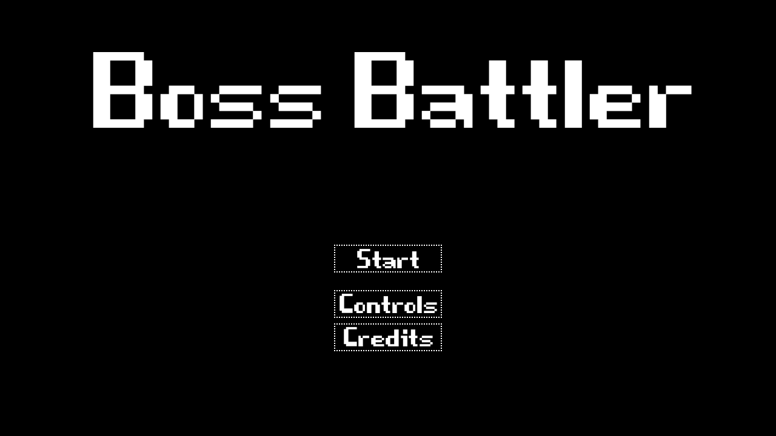

**Music:** 8-bit electronic background music.  
**SFX:** 8-bit beep for button presses.  
**Transitions:** Start > begin Level. Control > show controls. Credits > roll credits.

Level

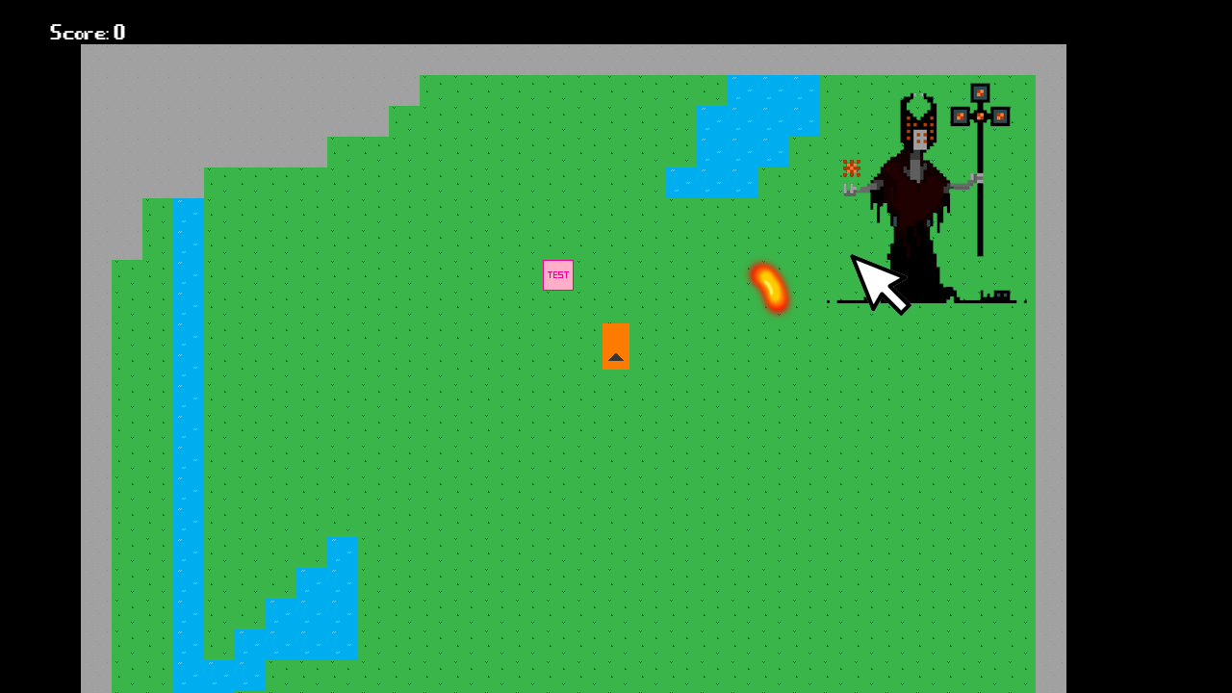

**Music:** Fast pace 8-bit electronic music.  
**SFX:** Shoot, hit boss, hit by boss, die, win  
**Transitions:** Loss all health > Game Over. Defeat boss > Win.

Control character with WASD, shoot projectiles with left click.

The objective is to destroy the boss by shooting projectiles at him while avoiding his attacks.

Game Over

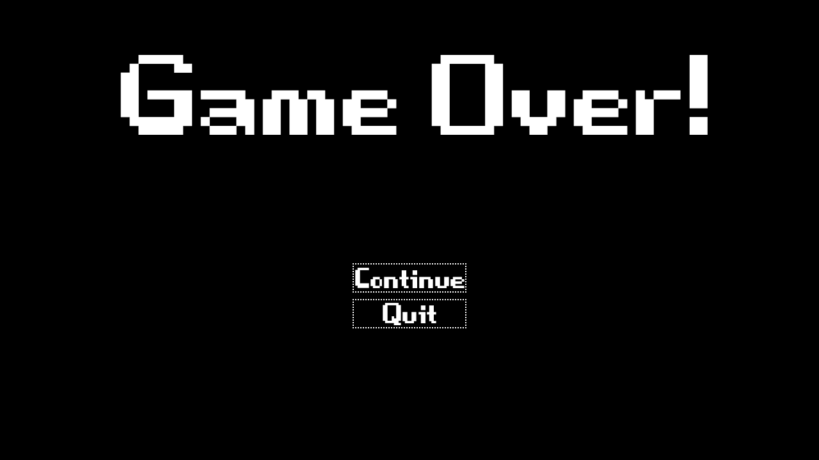

**Music:** Slow 8-bit electronic music.  
**SFX:** 8-bit beep for button presses.  
**Transitions:** Continue > back to Level. Quit > exit game.

Win

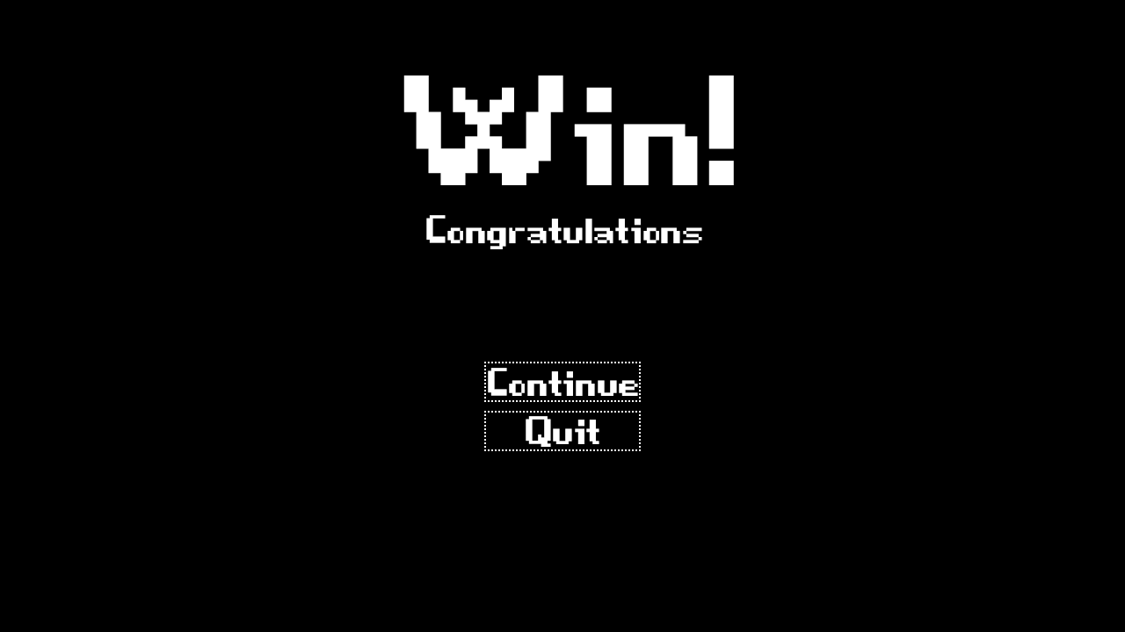

**Music:** Cheerful 8-bit electronic music.  
**SFX:** 8-bit beep for button presses.  
**Transitions:** Continue > retry Level 1. Quit > exit game.

Controls

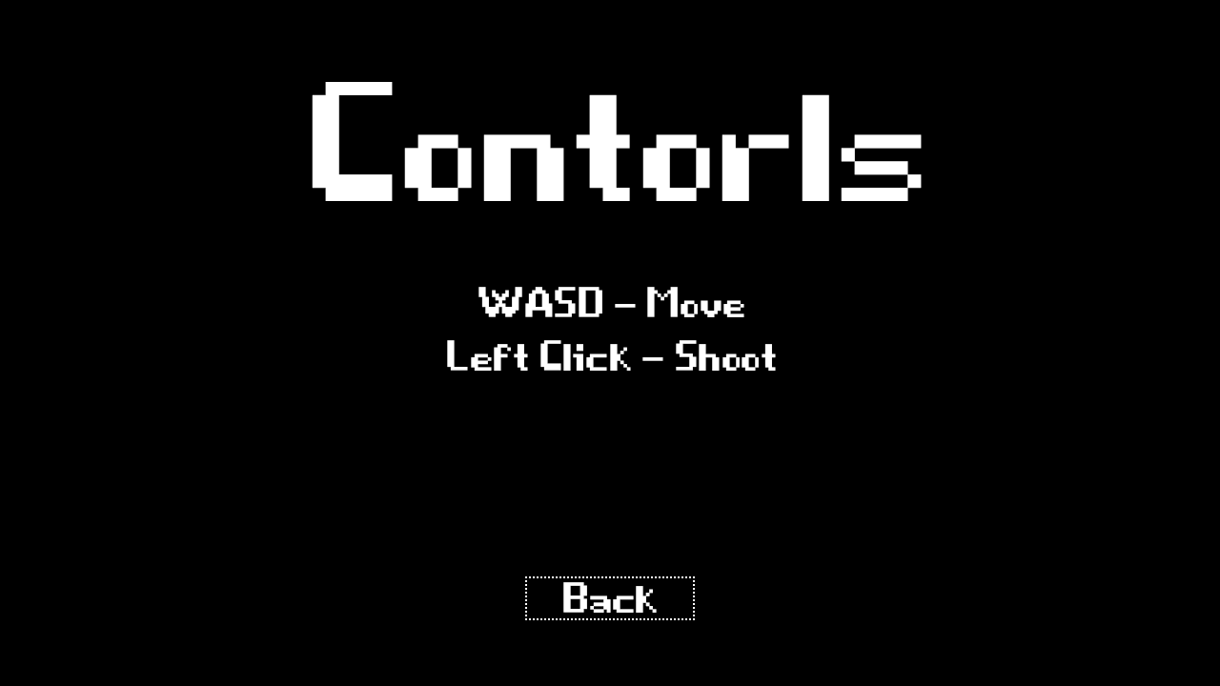

**Music:** 8-bit electronic background music.  
**SFX:** 8-bit beep for button presses.  
**Transitions:** Back > Main Menu.

Credits

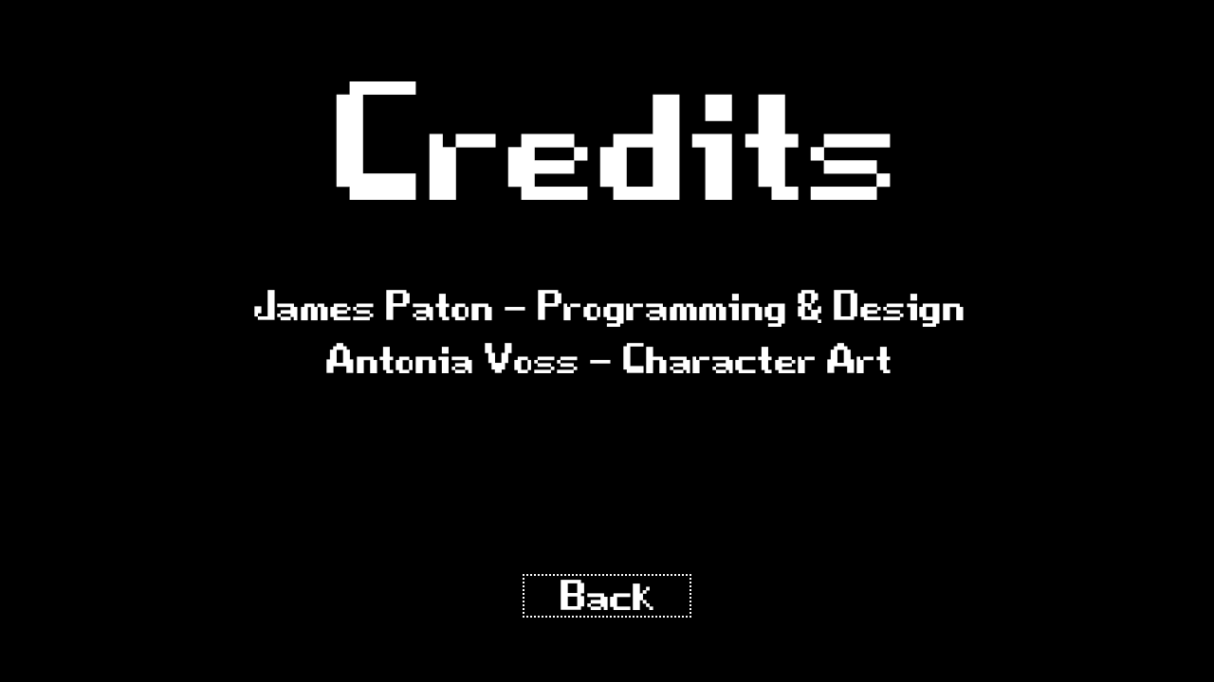

**Music:** 8-bit electronic background music.  
**SFX:** 8-bit beep for button presses.  
**Transitions:** Back > Main Menu.

References

Antonia Voss – Character Art (Not yet included)

Boss Character by lionheart963 (Illustration purposes only)  
https://lionheart963.itch.io/sorcerer-villain

Font - Game Over  
https://www.dafont.com/game-over.font